***Assignment 3***



Name:

FCU ID:

Team number:

**Topic of this class: Excel calculation**

Nowadays, software become indispensable tools in our work. Base on the functions and application conditions, software can be classified into three broad categories including system software, programming software and application software. For many of engineering/business related companies of industries, professional certification of software is a designation earned by a person to assure qualification to perform a job.

When solving an engineering/business problem, several types of software can be applied to assist calculation, statistics, graphing, modelling and testing. These are important tools for engineer to provide accurate information and quantitative data in their tasks. In this class, you will try to apply Excel, which it is one of the most common application software, in your calculation to finish the following questions.

|  |
| --- |
| **Learning objectives:**  *New abilities:*   * **ET01:** Use built-in cell referencing and functions for efficiency of calculations. * **ET02:** Select appropriate graphical representation of dataset based on data characteristics such as numerical (discrete or continuous) or categorical (ordinal or nominal). * **ET03:** Justify graphical representation based on data characteristics. * **ET04:** Prepare chart or table for technical presentation with proper formatting (headers, units, meaningful decimal points, appropriately scaled axes, appropriately sized marker and axis labels). * **DA01:** Describe, with calculations, the central tendency of data using descriptive statistics (mean, median, and mode). * **UC01:** Demonstrate an understanding of conservation principles (mass, energy, momentum, and/or charge) in a boundary system. * **UC02:** Describe systems or processes using schematic diagrams with inputs, outputs, and accumulations. * **SQ01:** Use accurate, scientific, mathematical, and/or technical concepts, units, and/or data in solutions.   ***You will be graded on completion of the above objectives!*** |

1. **Individual activity: Calculation practice 1.**
   1. Study the data below and try to calculate it with Excel built-in formulas:

1. Total payments of each month,

2. Total payments of the year,

3. The highest and lowest payment of the year,

4. Monthly average,

5. Average and standard deviation of each season.

Please copy your calculation tables and paste it in the following answer columns. Some of the questions might need more than one step. Always remember to put **Unit** with your answers.

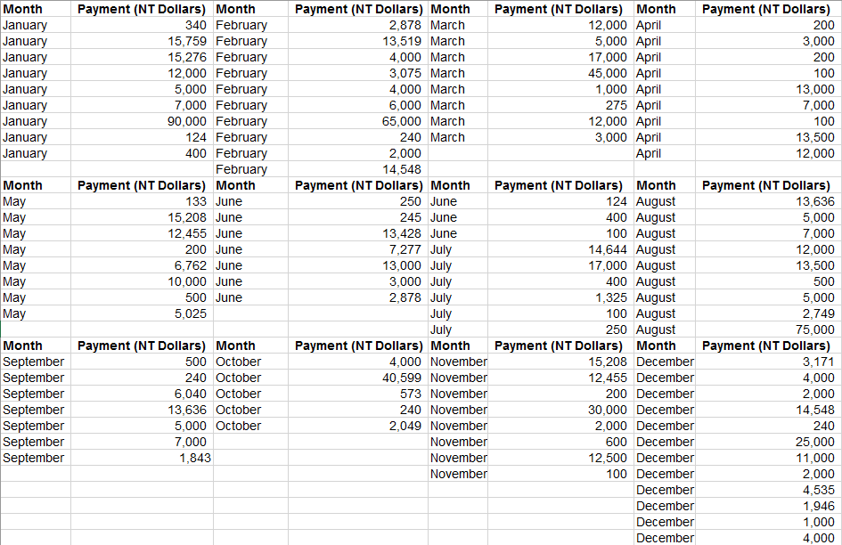

**Answer columns:**

|  |
| --- |
| 1. **Total payments of each month** |
|  |
| 1. **Total payments of the year** |
| **892,846** |
| 1. **The highest and lowest payment of the year** |
| **MAX:90,000**  **MIN:100** |
| 1. **Monthly average** |
|  |
| 1. **Average and stander deviation of each season** |
|  |

* 1. Try to design a simple program with excel to combine all of above calculations together.

|  |
| --- |
| **Calculation program** |
|  |

* 1. Introduce your program to your teammates and receive some feedbacks to improve it.

|  |
| --- |
| **Feedback** |
|  |
|  |
|  |
|  |

1. **Individual activity: Calculation practice 2.**

In this practice, you will need to type some equations by yourself for further calculation.

2-1. Try to calculate the following geometric and trigonometric questions with excel. Put your equation, calculation tables and answers in the answer columns below. Always remember to put **Unit** with your answers.

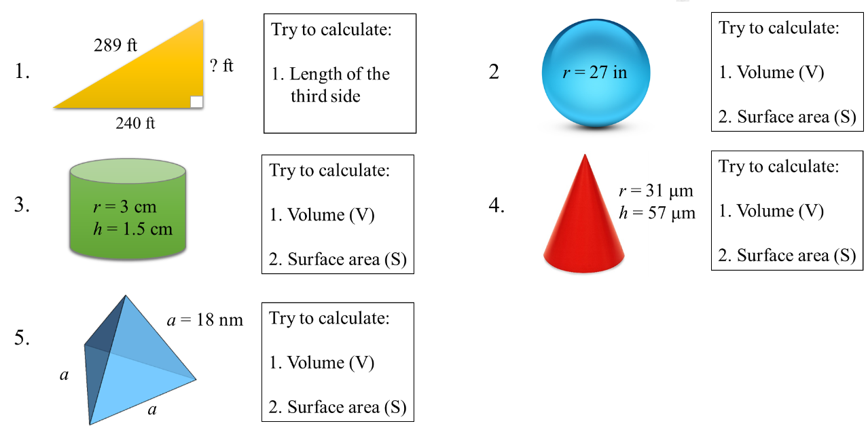

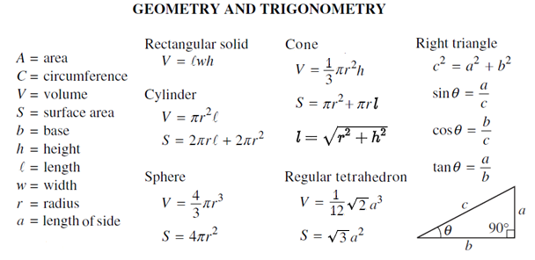

|  |
| --- |
| **Answer columns 2-1-1.** |
|  |
| **Answer columns 2-1-2.** |
|  |
| **Answer columns 2-1-3.** |
|  |
| **Answer columns 2-1-4.** |
|  |
| **Answer columns 2-1-5.** |
|  |

1. **Team activity: How to present results?**

Sometimes text and number are not direct enough to present your results. In this case, a more organized way is required to applied to do so. Discuss this topic with your teammates and put your answers in the column below.

|  |
| --- |
| **How to present results?** |
|  |

1. **Individual activity: Engineering calculation 1**

***Ideal gas law***

The Ideal Gas Law is a combination of simpler gas laws such as Boyle's, Charles's, Avogadro's and Amonton's laws, which is simply expressed as:

***PV =nRT***

Where:

|  |  |
| --- | --- |
| Pis pressure | R is universal gas constant 0.08206 L·atm/K·mol |
| V is volume | T is temperature |
| n is number of mole of gas |  |

4-1. Populate a table to determine the pressure of 3 mole N2 in the conditions of chamber volume ranging from 5 to 30 L in increments of 5 L, and temperature ranging from 233 K to 313 K in increments of 10 K.

|  |
| --- |
| **Answer column for question 4-1** |
|  |

4-2. Try to populate another table if we change the temperature ranging as from 122 Fahrenheit (°F) to 248 °F in increments of 18 °F. ([°F] = [K] ×  9⁄5 − 459.67)

|  |
| --- |
| **Answer column for question 4-2** |
|  |

1. **Individual activity: Engineering calculation 2**

***Dielectric mirror***

Dielectric mirror, also known as a Bragg mirror, is an optical mirror made of thin layers of dielectric coating deposited on an optical substrate. A dielectric mirror is design to approach absorption–free from light, which is one kind of useful coatings applied on optical and photoelectrical materials.

Dielectric mirrors function based on the interference of light reflected from the different layers of dielectric stack. To design a dielectric mirror, we need to make sure that the thickness of each layers is quarter of the wavelength, and the layers with a high refractive index n1 are interleaved with the layers with a lower refractive index n2. In here, we usually setup refractive index n0 and n3 for air and substrate, respectively. The schematic diagram and the equation of maximum reflectivity is as following.

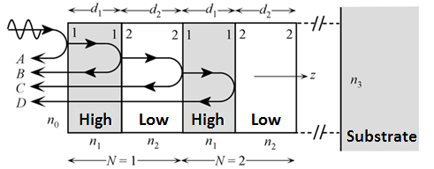



Where:

|  |  |
| --- | --- |
| RN is maximum reflectivity | n1 is the higher refractive index |
| N is the number of dielectric layer pair | n2 is the lower refractive index |
| n0 is the refractive index of the air | n3 is the refractive index of substrate |

5-1. For choosing Ta2O5 (n = 1.78) and SiO2 (n = 1.55) as the layers for six different types of substrate (n = 1.18, 1.47, 1.65, 1.92, 2.03, & 2.79). Try to populate a table to determine the maximum reflectivity with N from 1 to 15. (n0 = 1 as air).

|  |
| --- |
| **Answer column for question 5-1** |
|  |

5-2. Once we replace SiO2 layer with TiO2 (n = 2.2), try to populate another table to determine the maximum reflectivity with N from 1 to 15. (n0 = 1 as air).

|  |
| --- |
| **Answer column for question 5-1** |
|  |

5-3. Try to plot a diagram to present the results of maximum reflectivity change with substrate and N for question 5-1 & 5-2.

|  |
| --- |
| **Answer column for question 5-3** |
|  |

5-4. If engineers want to approach 99.9% of maximum reflectivity for all the dielectric mirror & substrate set. Which set required maximum number of N? What is the number of N?

|  |
| --- |
| **Answer column for question 5-4** |
| N=30 |

1. **Individual contributions**

Individually, each team member should describe his/her contributions to these activities.

|  |  |
| --- | --- |
| **Team member name** | **Team members’ contribution to the team activities above** |
|  |  |
|  |  |
|  |  |
|  |  |